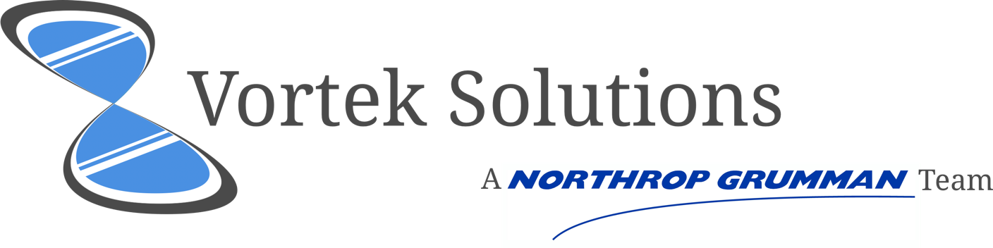

Prototype 2 Meeting Agenda

Wednesday, April 19,2017; 3 – 4 p.m.

Members:

Justin Goulet, Chris Larsen, Mikal Callahan, Brock Corbett

# Prototype 1 Meeting Agenda

## Roll Call

|  |  |
| --- | --- |
| Member Name | Is Present |
| Justin Goulet |  |
| Christopher Larsen |  |
| Mikal Callahan |  |
| Brock Corbett |  |
| Dr. Shauninn-Wu |  |
| Thomas (Ty) Usrey |  |

|  |  |
| --- | --- |
| Meeting Start | Meeting Adjournment |
| XX:XX XM | XX:XX XM |

## Topics of Discussion:

|  |  |
| --- | --- |
| Outstanding Issues: | JSON object update  Wireframe Design approval  Overview of project team’s progress |

|  |  |
| --- | --- |
| New Agenda Items |  |
| Justin Goulet | **Project Deliverables:**  How will this project be delivered to Ty? Flash Drive? GitHub Access? Email?  **Project Readme:**  One long document for each, or documents that link together?   * MS Word can link to different document * HTML pages can be limited on what is shown to user at a time * Currently have 2 HTML Readme’s (on Github)   **GitHub Pages Update:**  All live code is now viewable on our GitHub Pages site. This site, while does not show the code, shows a representation of our progress. |
| Chris Larsen | **View Updates:**  Initial node view now shows grid with workflow metadata.   * Added button to display workflow metadata (id, owner, status…) * State data is held in each node. * Comments/questions/concerns? |
| Mikal Callahan | **Design Schema:**  The widget more closely resembles the wireframes  Are there any last minute design specs to be added?  In the event that we do switch frameworks, theming will have to start over from scratch |
| Brock Corbett | **Alternative Framework:** Would there be a conflict of transitioning to a different framework? |